# 

# 

# 

# 

# 

# 

# 

# **Peanut Butter: Final Project**

# 

# 

# 

# 

# 

# 

# 

# 

# 

# 

# 

# 

# 

# 

# 

# **MKTG-6332-01-SU22: Buyer Behavior Analysis**

Tony Adamson, Brandy Beucler, Lisa Calixto, and Victoria Chung

June 14, 2022

# 

# 

# **Part I: CrossTabs/Chi-Square Analysis**

Conduct the following CrossTabs with Chi-Square significance tests. Significance level .05. Hint: Highlighting the cells where the count exceeds the expected count will help show the pattern.

Table

| **Test** | **Rows** | **Columns** |
| --- | --- | --- |
| 1 | pmarial | brandcat1 |
| 2 | sex | brandcat1 |
| 3 | region | brandcat1 |
| 4 | agegroup | brandcat1 |
| 5 | likelyaction | brandcat1 |
| 6 | prchaseintent | brandcat1 |

In your presentation, please address the following questions:

Test 1: marital status (***pmarital***) and Brand of Category Purchased Most of (***brandcat1***)

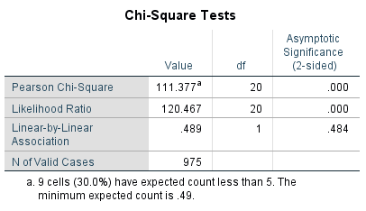

The p-value <. 05; Reject H0

There is a significance between marital status and the brand of peanut butter purchased most with a value of .000.

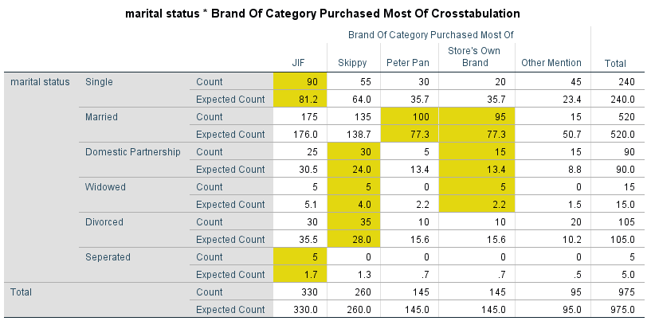

1. Which group(s) prefers JIF  
Single and Separated

2. Which group(s) prefer Skippy, Peter Pan and the Store Brand   
Skippy: Domestic partner, widowed, and divorced  
Peter Pan: Married  
Store Brand: Married, Domestic Partner, and widowed

Test 2: gender (***sex***) and Brand of Category Purchased Most of (***brandcat1***)

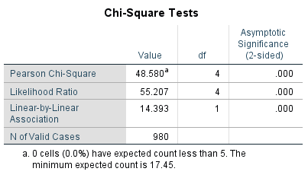

The p-value <. 05; Reject H0

There is a significance between gender and the brand of peanut butter purchased most with a value of .000.

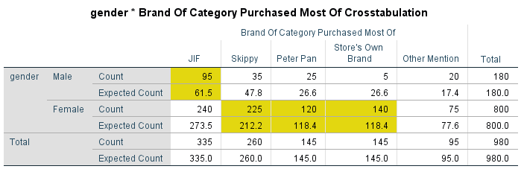

1. Which group(s) prefers JIF  
Male

2. Which group(s) prefer Skippy, Peter Pan and the Store Brand   
Skippy: Female  
Peter Pan: Female

Store Brand: Female

Test 3: region (***region***) and Brand of Category Purchased Most of (***brandcat1***)

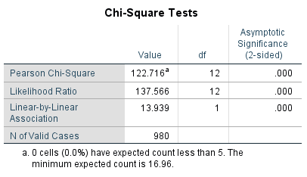

The p-value <. 05; Reject H0

There is a significance between region and the brand of peanut butter purchased most with a value of .000.

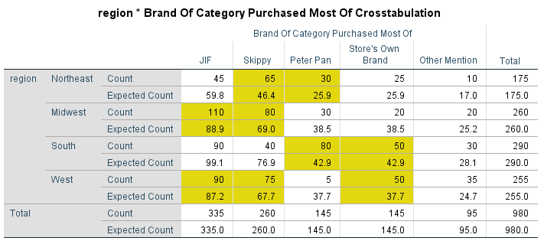

1. Which group(s) prefers JIF  
Midwest and the West

2. Which group(s) prefer Skippy, Peter Pan and the Store Brand  
Skippy: Northeast, Midwest, West  
Peter Pan: Northeast, South  
Store Brand: South, West

Test 4: What age group are you in (***agegroup***) and Brand of Category Purchased Most of (***brandcat1***)

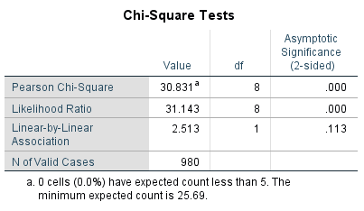

The p-value <. 05; Reject H0

There is a significance between age groups and the brand of peanut butter purchased most with a Chi-Square value of .000.

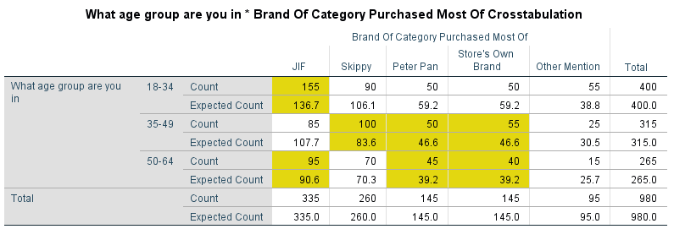

1. Which group(s) prefers JIF  
18-34, 50-64

2. Which group(s) prefer Skippy, Peter Pan and the Store Brand  
Skippy: 35-49

Peter Pan: 35-49, 50-64

Store Brand: 35-49, 50-64

Test 5: Likely alternative action (***likelyaction***) and Brand of Category Purchased Most of (***brandcat1***)

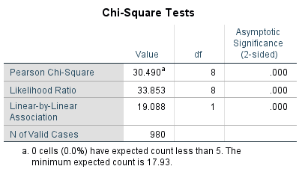

The p-value <. 05; Reject H0

There is a significance between the likely alternative action a customer takes when their brand of choice isn’t available and the brand of peanut butter purchased most indicated with a Chi-Square value of .000.

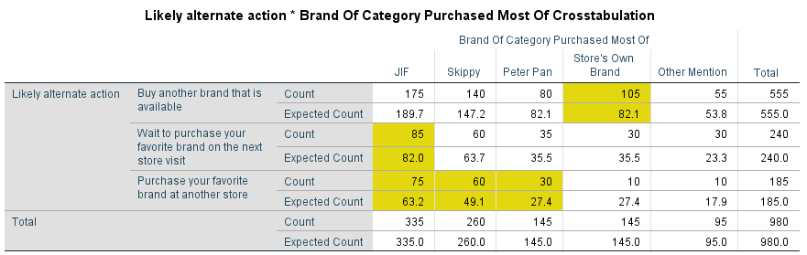

1. Which group(s) prefers JIF  
Wait to purchase your favorite brand on the next store visit, and Purchase your favorite brand at another store

2. Which group(s) prefer Skippy, Peter Pan and the Store Brand  
Skippy: Purchase your favorite brand at another store  
Peter Pan: Purchase your favorite brand at another store

Store Brand: Buy another brand that is available

Test 6: Purchase intent (***prchaseintent***) and Brand of Category Purchased Most of (***brandcat1***)

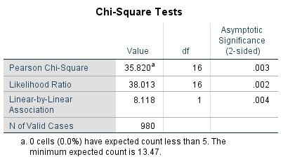

The p-value <. 05; Reject H0

There is a significance between a customer’s purchase intent and brand of choice indicated with a Chi-Square value of .003.

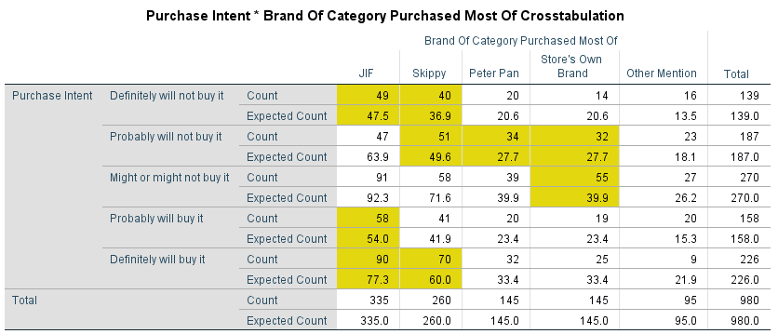

1. Which group(s) prefers JIF  
Definitely will not buy it, Probably will buy it, and Definitely will buy it

2. Which group(s) prefer Skippy, Peter Pan and the Store Brand  
Skippy: Definitely will not buy it, Probably will not buy it, and Definitely will buy it  
Peter Pan: Probably will buy it

Store Brand: Probably will not buy it, and Might or might not buy it

# **Part II: Dummy and Multiple Regression**

The variables needed for this analysis are Purchase Intent (***prchaseintent***), Brand Of Category Purchased Most Of (***brandcat1***), Likely Alternate Action (***likelyaction***), Relevance (***relevance***), Commitment (***commitment***), Popular (***popular***), and Price Evaluation (***priceevalu***).

Using dummy regression, determine which of the brands (JIF, Skippy, Peter Pan and Store Brand) is most likely to be purchased and the likely action a customer is likely to take if their favorite brand is not available.

1. First, compute dummy variables for the ***brandcat1*** variable and ***likelyaction*** variable

a. Use the *Create Dummy Variables* under Transform to do this

b. For ***brandcat1***, set Store’s Own Brand as the base condition. You will create 3 dummy variables for ***brandcat1***. The first one will be JIF coded 1, and the next one will be Skippy coded 1, and Peter Pan coded 1. When entering the variables, enter JIF first, Skippy second and Peter Pan third.  
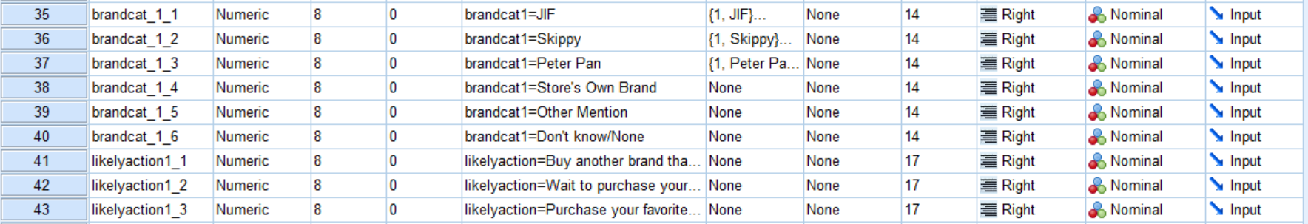

c. For ***likelyaction***, set “Buy another brand that is available” as the base condition. You will create 2 dummy variables for ***likelyaction***. The first one will be “Wait to purchase your favorite brand on the next store visit” and the other one will be “Purchase your favorite brand at another store.” Enter these two variables in the equation after the 3 ***brandcat1*** variables. Enter “Wait to purchase your favorite brand on the next store visit” as the fourth variable after Peter Pan. Then enter Purchase your favorite brand at another store as the last variable.

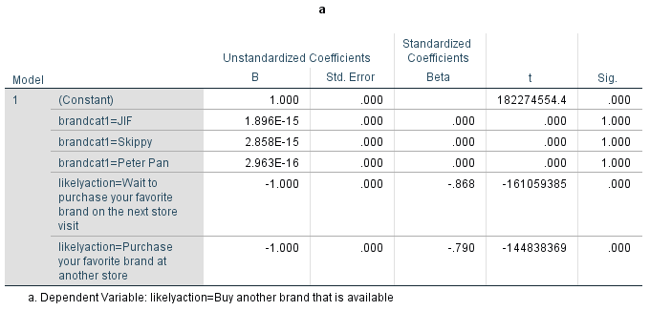

2. Enter Purchase Intent (***prchaseintent)*** as the dependent variable and select okay. You should have a regression model with 5 coefficients.   
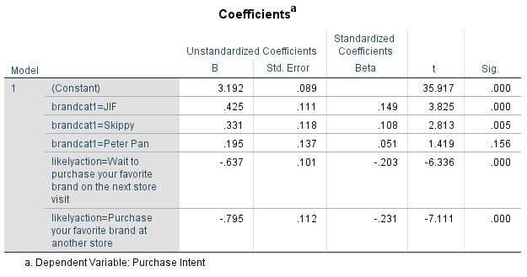

3. Answer the following questions in your presentation.

a. Which brand is most likely to be purchased?  
JIF

b. Which brand is the second most likely to be purchased?  
Skippy

c. The coefficient for Peter Pan is not significant. What does that mean?  
If the p-value is less than .05 it means there is no relationship. The Peter Pan brand is not doing anything. You would not use it in the equation.

d. What is the most likely alternative action that will be taken by the customer if their favorite brand is not available?  
Buy another brand that is available

Using multiple regression determine if there are any differences between the three brands (JIF, Skippy, and Peter Pan) regarding Purchase Intent (***prchaseintent***) based on the four independent variables relevance (***relevance***), commitment (***commitment***), popular(***popular***), and price evaluation (***priceevalu***). Note: This is a separate regression model from the one above. **Do not** include the ***brandcat1*** and ***likelyaction*** dummy variables in this equation. **Only use the four independent variables listed here**.

1. You will use Data> Select Cases to calculate the results for the three brands using the regression model. On the Select Cases dialog box select “If condition is satisfied.” In the next dialog box select ***brandcat1*** and enter = 1. This sets the data to use only the JIF responses.  
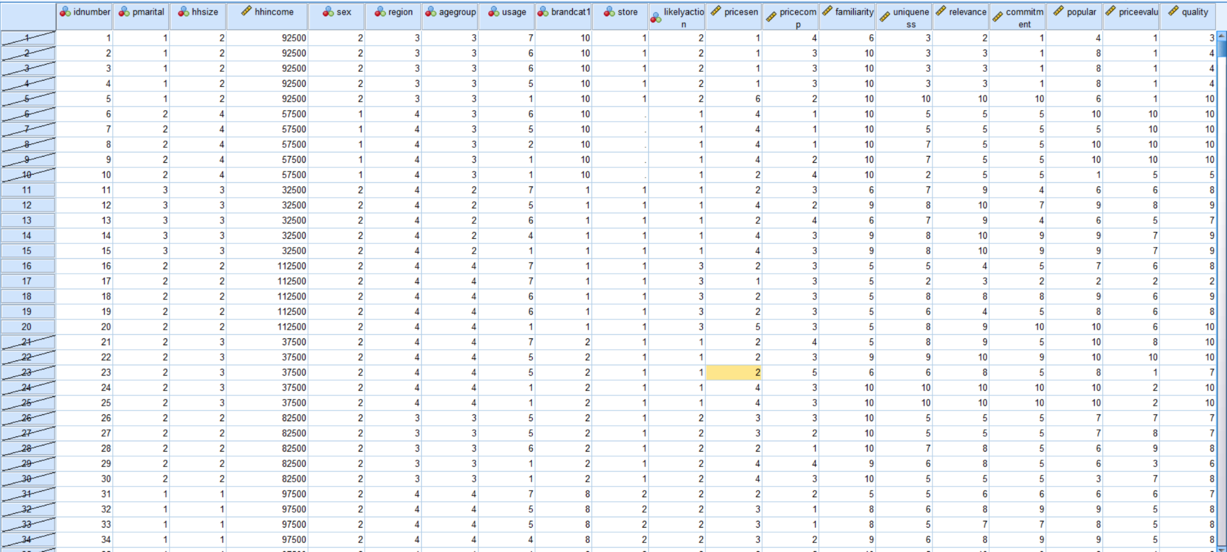

2. Create the multiple regression model with Purchase Intent (***prchaseintent***) as the dependent variable with the four independent variables relevance (***relevance***), commitment (***commitment***), popular(***popular***), and price evaluation (***priceevalu***). Select okay. Note the coefficients and significance of the coefficients. These are the results for JIF.

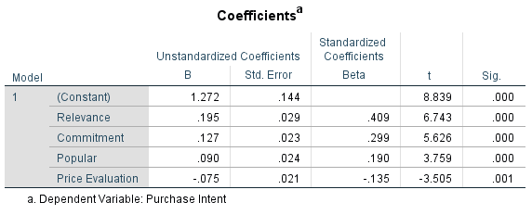

3. Under Data> Select Cases, change the condition for ***brandcat1*** to =2. This sets the data to use only Skippy responses.

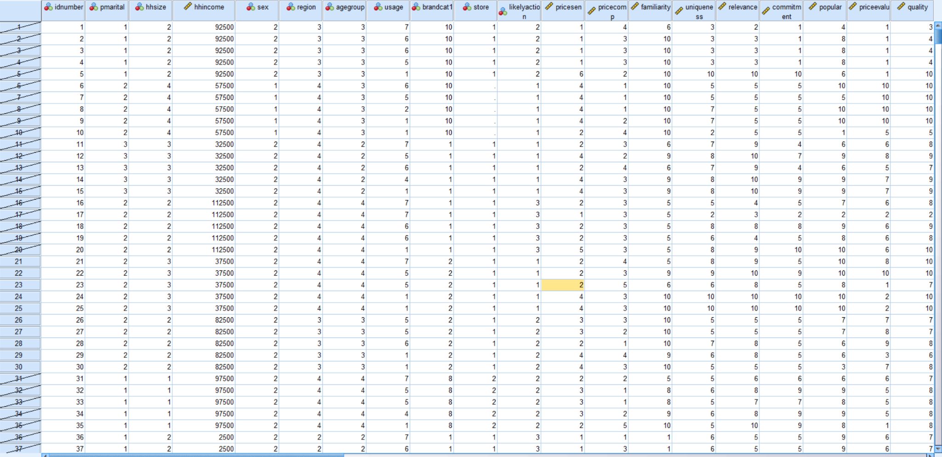

4. Re-run the regression model. Note the coefficients and significance of the coefficients. These are the results for Skippy.

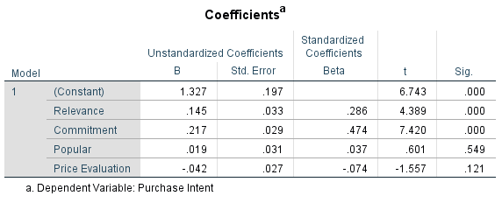

5. Under Data> Select Cases, change the condition for brandcat1 to =3. This sets the data to use only Peter Pan responses.  
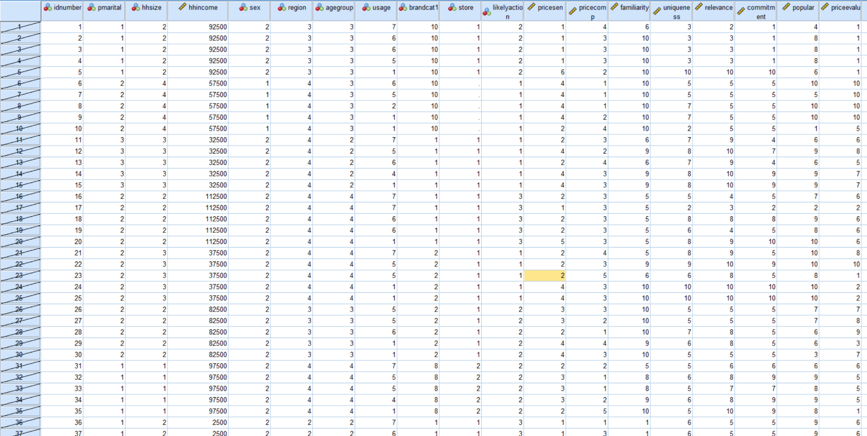

6. Re-run the regression model. Note the coefficients and significance of the coefficients. These are the results for Peter Pan.

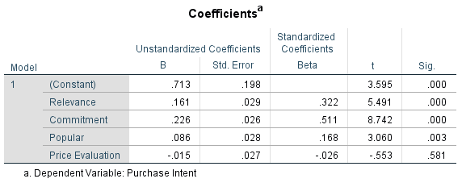

7. In your presentation address the following questions. To answer these questions, you compare the coefficients for each variable in the three models.

a. Which brand has the highest relevance?  
JIF

b. Which brand has the highest commitment?  
Peter Pan

c. Which brand is the most popular?  
JIF

d. Which brand do customers evaluate the price the most?  
JIF

**APPENDIX**

**CrossTabs**

**Test 1**

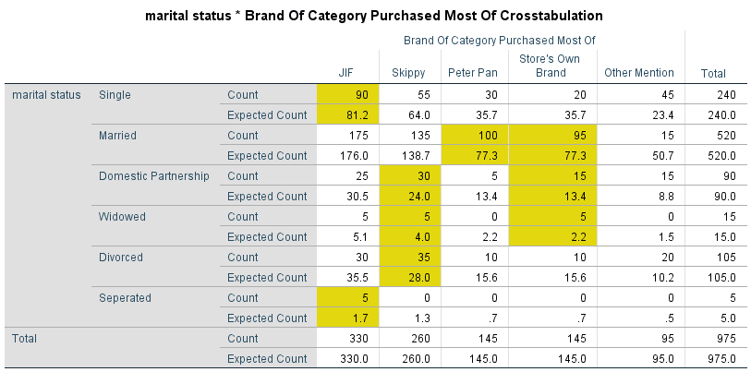

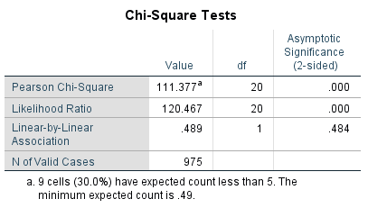

**Test 1**

**Test 3**





**Test 4**





**Test 5**





**Test 6**





**Dummy Regression**

**Test 1**

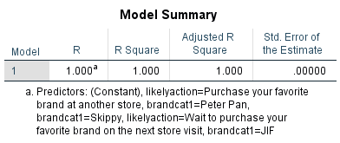

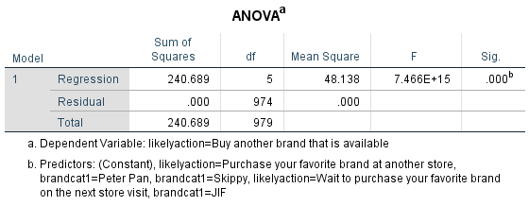

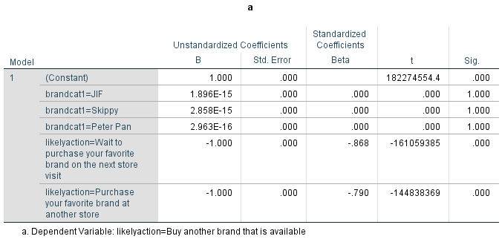

# **Test 2**

# 

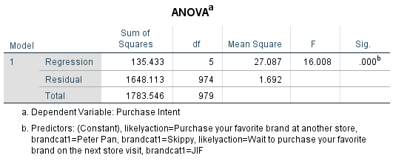

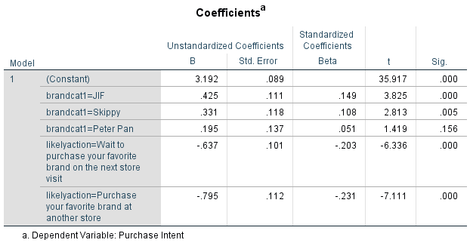

**Multiple Regression**

**JIF  
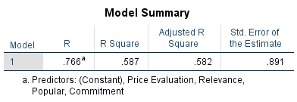  
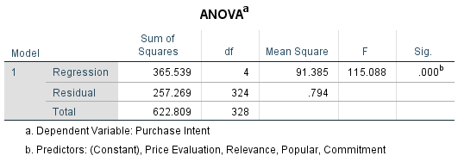**

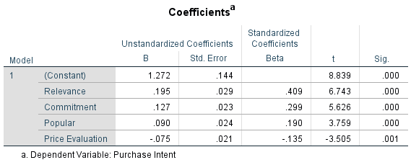

**Skippy**

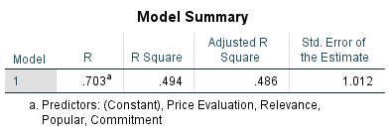

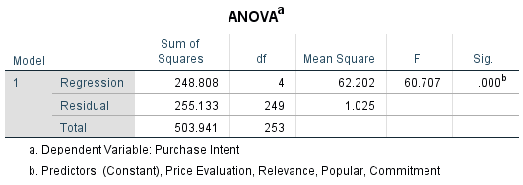

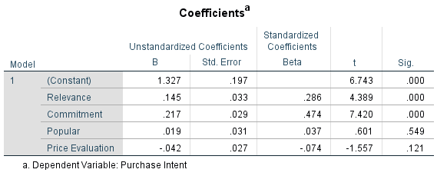

**Peter Pan**



 

 